 |  |  |  |  |  |  |  |  |  | curriculum.newvisions.org/social-studies  Timothy Lent - tlent@newvisions.org  Kameelah Rasheed - krasheed@newvisions.org | 
Please Read: We encourage all teachers to modify the materials to meet the needs of their students. To create a version of this document that you can edit:  1. Make sure you are signed into a Google account when you are on the resource.  2. Go to the "File" pull down menu in the upper left hand corner and select "Make a Copy." This will give you a version of the document that you own and can modify. |  |  |  |  |  |  |  |  |  |  | 
Teacher Overview: What was the Renaissance?
Go directly to student-facing materials!

 | SQ 2. What was the geographic context for transformation of Western Europe and Russia in the 15th century? | SQ 3. What was the Renaissance? |  | SQ 4. What are the geographic and historical circumstances that led to the start of the Renaissance in Italy? | 

 | Unit Essential Question(s): How did new ideas and innovation affect Western Europe and Russia starting in the 15th century? | Link to Unit
Supporting Question(s):
- What was the Renaissance?
Objective(s):
- Describe the characteristics of the Renaissance.

1. NYS Social Studies Framework:
Key Idea | Conceptual Understandings | Content Specifications
9.9 TRANSFORMATION OF WESTERN EUROPE AND RUSSIA: Western Europe and Russia transformed politically, economically, and culturally ca. 1400–1750. This transformation included state building, conflicts, shifts in power and authority, and new ways of understanding their world.  (Standards: 2, 3, 5; Themes: ID, MOV, TCC, GOV, CIV, TECH, EXCH) | 9.9a The Renaissance was influenced by the diffusion of technology and ideas. The Islamic caliphates played an important role in this diffusion. | Students will investigate technologies and ideas, including printing and paper, navigational tools, and mathematics and medical science that diffused to Europe, noting the role of the Islamic caliphates.  Students will explore shifts in the Western European Medieval view of itself and the world as well as key Greco-Roman legacies that influenced Renaissance thinkers and artists.

2. Social Studies Practices
NYS Social Studies Practices | New Visions Student Social Studies Practices
Gathering, Using and Interpreting Evidence (A2, A5, A7)  Chronological Reasoning and Causation (B1, B5, B7)  Comparison and Contextualization (C1, C3, C5, C6)  Geographic Reasoning (D1, D2, D5) | Contextualize Predict

3. Common Core
Reading | Writing | Speaking and Listening
Craft and Structure:  CCSS.ELA-LITERACY.RH.9-10.4: Determine the meaning of words and phrases as they are used in a text, including vocabulary describing political, social, or economic aspects of history/social science.  Integration of Knowledge and Ideas:  CCSS.ELA-LITERACY.RH.9-10.7: Integrate quantitative or technical analysis (e.g., charts, research data) with qualitative analysis in print or digital text. | Text Types & Purposes:  CCSS.ELA-LITERACY.WHST.9-10.1: Write arguments focused on discipline-specific content. | Comprehension and Collaboration:  CCSS.ELA-LITERACY.SL.9-10.1: Initiate and participate effectively in a range of collaborative discussions (one-on-one, in groups, and teacher-led) with diverse partners on grades 9-10 topics, texts, and issues, building on others' ideas and expressing their own clearly and persuasively.

Associated Classroom Posters
Student Social Studies Practices Poster

Objective: | What was the Renaissance?  - Describe what the Renaissance was.

Introduction
➡ Directions: Read the definition of a Golden Age and the conditions necessary for one on the right, then select one golden age from your study of Global History and describe the conditions that led to its prosperity in the table on the left.

Choose one of the golden ages listed below and fill in the chart based on it.  Gupta Golden Age Han Dynasty Pax Romana Golden Age of Athens  Pax Mongolica Abbasid Golden Age Tang and Song Dynasties  Golden Age: _________________________  Wealth Stable Government Ideas it Built On Contributions and Achievements |  | Golden ages are periods of great wealth, prosperity, stability, and cultural and scientific achievement.
 |  | There are three conditions necessary for what historians call a “golden age”:
 |  | 1. Wealth | Since artists and architects do not produce food for themselves, they need money to buy it. For a civilization to free up these creative people and give them time and the resources they need to produce great works of art and to make scientific discoveries, wealthy people, or a government with a surplus of money, need to fund those projects.
 |  | 2. Stable Government | Though a lot of impressive art has been inspired by unstable times, it is difficult to build structures that will last if the architects and construction workers are pulled away from the project to go to war. It is also hard to protect writings, paintings, and books from invading armies that burn libraries, or capture or kill scientists and artists.
 |  | 3. Ideas to Build On | Most artistic and scientific achievements in human history have been innovations on previous ideas. Often, golden ages occurred where artists and scientists had access to knowledge from previous scholars who worked in universities or libraries, or where the ideas of many cultures came together in one place, like an important trading city.

Predict | Historical Context of the Start of the Renaissance  ➡ Directions: Examine the images and read the information provided, then complete the prompts to review some of European history before the Renaissance.

Timeline of Western Europe
Rome  (27 BCE- 476 CE) | Middle Ages  (476 CE- 1400s) | Renaissance  (1300s- 1600s)

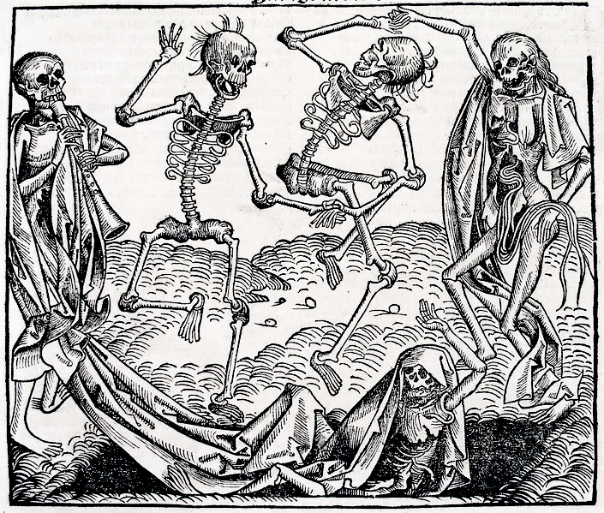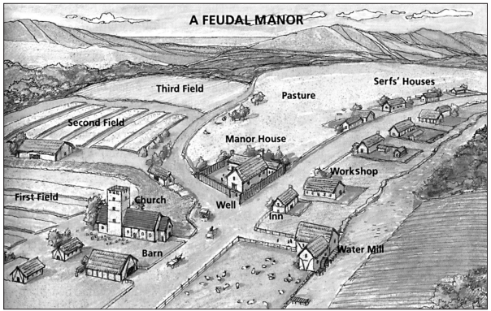

Feudal System
The Black Death
Manorialism
Black Death image is courtesy of Wikimedia Commons and is public domain.
Source: Michael B. Petrovich et al., People in Time and Place: World Cultures, Silver, Burdett & Ginn, 1991 from the NYS Global History and Geography Regents Exam, January 2006
1. What do you remember about... |  |  | 2. How was the period when Rome ruled most of Europe different from the Middle Ages?
1a. The Feudal System | 1b. The Black Death | 1c. Manorialism

Timeline of Western Europe
Rome  (27 BCE- 476 CE) | Middle Ages  (476 CE- 1400s) | Renaissance  (1300s- 1600s)

THE  MIDDLE AGES  (476 CE- 1400s)  The Black Death killed off ⅓ of all Europeans.  The Feudal System held many people from social advancement.  People were isolated in their kingdoms. The manor was the center of economic life.  Black Death image is courtesy of Wikimedia Commons and is public domain.  Source: Michael B. Petrovich et al., People in Time and Place: World Cultures, Silver, Burdett & Ginn, 1991 from the NYS Global History and Geography Regents Exam, January 2006 | 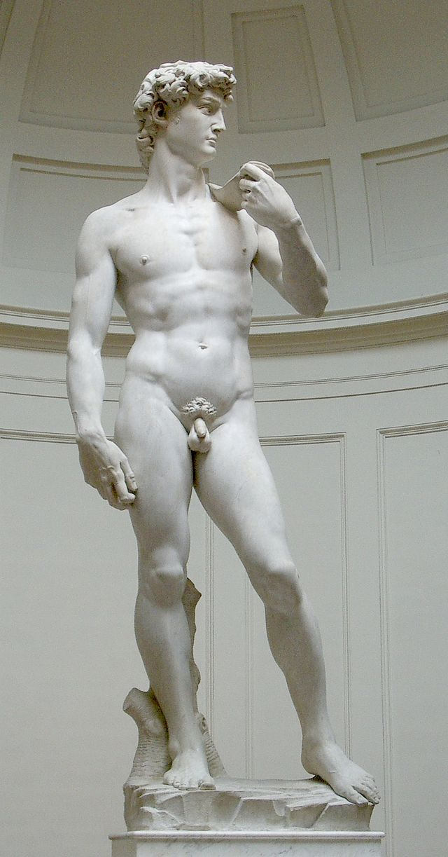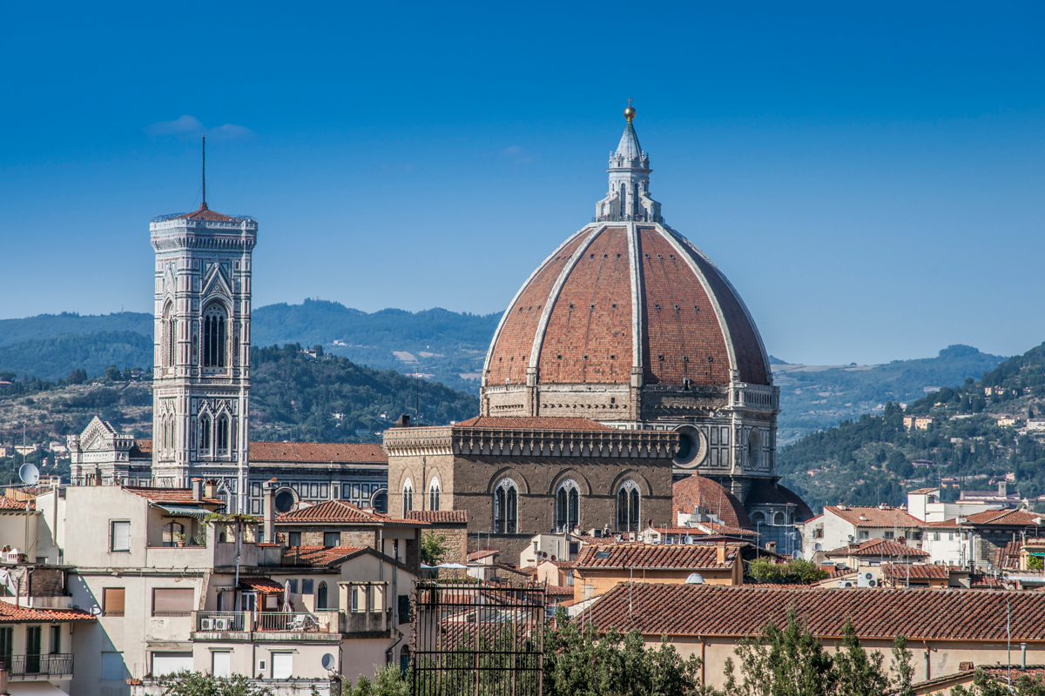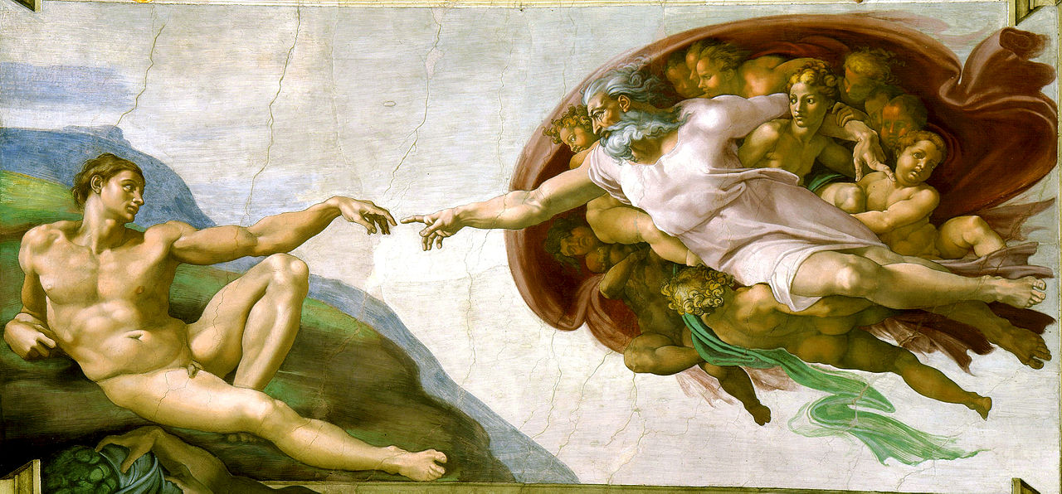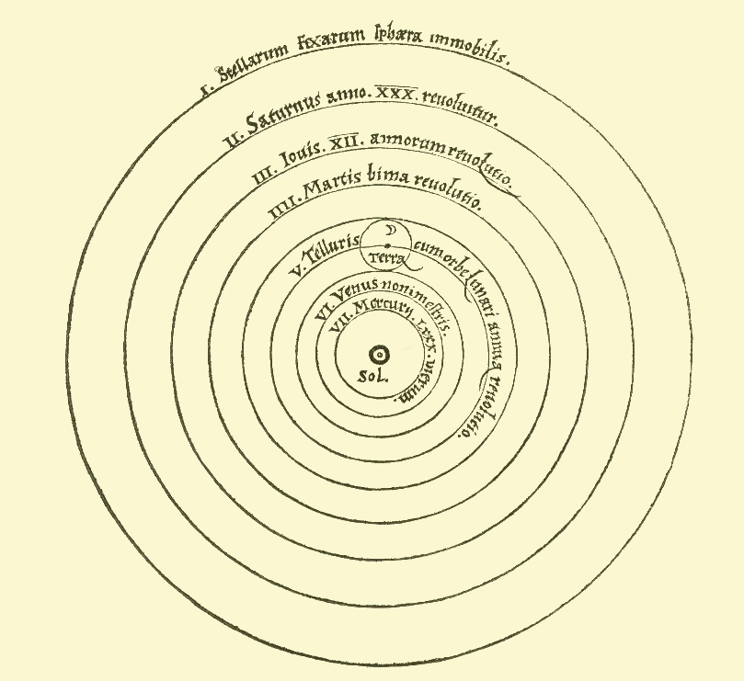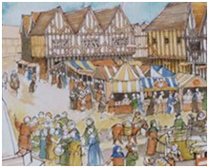  THE  RENAISSANCE(1300s- 1600s)  Merchants gained more wealth and power as trade expanded within Europe and with the Ottoman Empire  Artistic and scientific achievement flourished throughout Europe.  Medieval Grantham is published on MyLearning under a CC BY license  Sistine Chapel is courtesy of Wikimedia Commons and is public domain.  Image was created by Florian Hirzinger and is published on Wikimedia Commons under a CC BY license.  David is courtesy of Wikimedia Commons and is public domain.  Heliocentric drawing is courtesy of Wikimedia Commons and is public domain.
3. Based on the information and images above, make a claim and support it with evidence to answer the question: How could Europe have changed so much between the Middle Ages and the Renaissance?

Contextualize | What was the Renaissance?  ➡ Directions: Read the definition of the Renaissance, then complete each of the activities that breakdown and clarify that definition.

Re  again | + | naissance  “a birth, an origination as that of an idea, or a movement.” | = Renaissance

Definition | The Renaissance, “rebirth” in French, was a cultural movement in the 14th-17th centuries during which European artists, scientists, and scholars, were inspired by Classical achievements of the Greeks and Romans, which they became aware of through ruins and Greco-Roman texts preserved by Islamic scholars in the Ottoman Empire.

Timeline of Western Europe
Rome  (27 BCE- 476 CE) | Middle Ages  (476 CE- 1400s) | Renaissance  (1300s- 1600s)

Definition Activity 1

Definition | The Renaissance, “rebirth” in French, was a cultural movement in the 14th-17th centuries during which European artists, scientists, and scholars, were inspired by Classical achievements of the Greeks and Romans, which they became aware of through ruins and Greco-Roman texts preserved by Islamic scholars in the Ottoman Empire.

“cultural movement”= culture + movement  culture is the language, ideas, inventions, and art of a particular group of people.  a movement in history is a change |  | The Renaissance started in Italy in the 14th century (1300s), but its ideas and cultural trends spread slowly across Europe. The Renaissance marked the end of the Middle Ages, but they overlap. Depending on where in Europe a person was, the Renaissance “arrived” at a different time.    Like the Black Death, the Renaissance ideas started in Italy and then spread to the rest of Europe.  Image was adapted from a map created by Asarlai and is published on Wikimedia Commons under a CC BY license. | Questions  1. Identify one cultural change that you have seen in your lifetime.  2. Identify something from your life that one group of people knew before another because of their geographic location.
As an example of a cultural change, examine the two pairs of jeans below.

Note: The cultural change represented by these pairs of jeans was a lot less important than the cultural change during the Renaissance
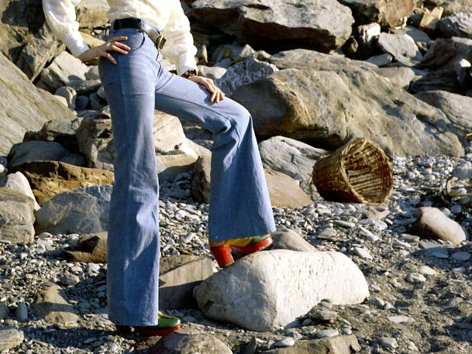  Bell bottom jeans were “cool” in the 1970s.  Image was created by Mike Powell and is published on Wikimedia Commons under a CC BY license. |   Acid wash jeans were “cool” in the 1980s.  Image was created by Abroe23 and is published on Wikimedia Commons under a CC BY license.

Definition Activity 2

Definition | The Renaissance, “rebirth” in French, was a cultural movement in the 14th-17th centuries during which European artists, scientists, and scholars, were inspired by Classical achievements of the Greeks and Romans, which they became aware of through ruins and Greco-Roman texts preserved by Islamic scholars in the Ottoman Empire.

Classical Art and Architecture |  | Renaissance Art and Architecture
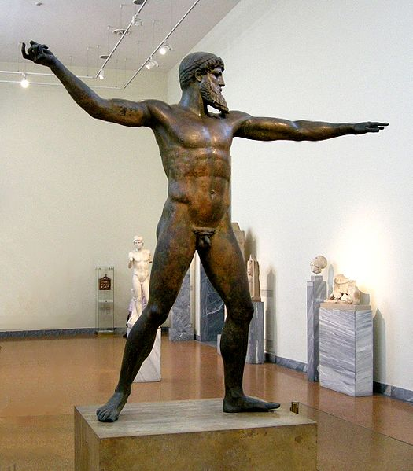 | 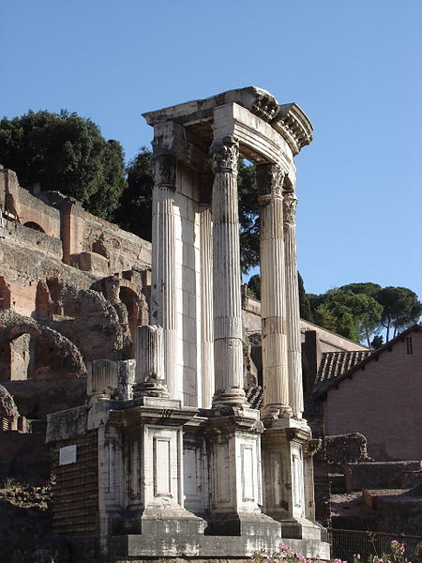 | 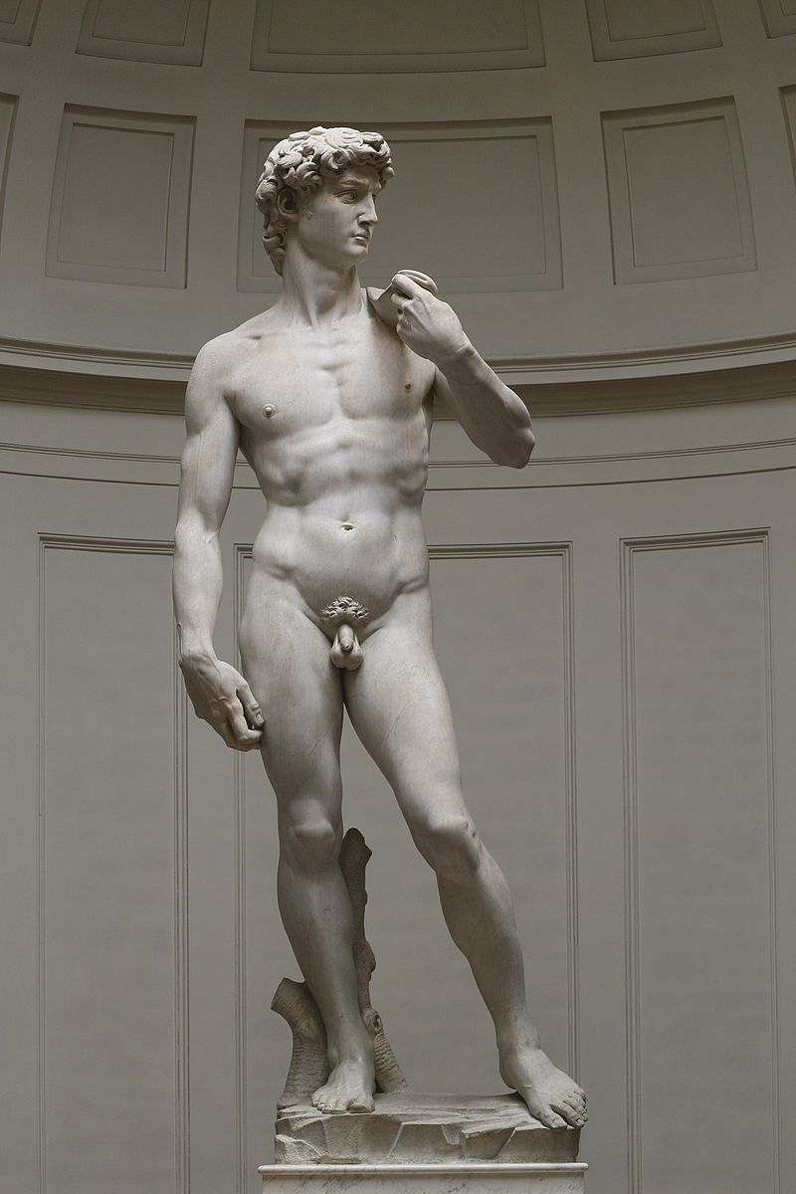 | 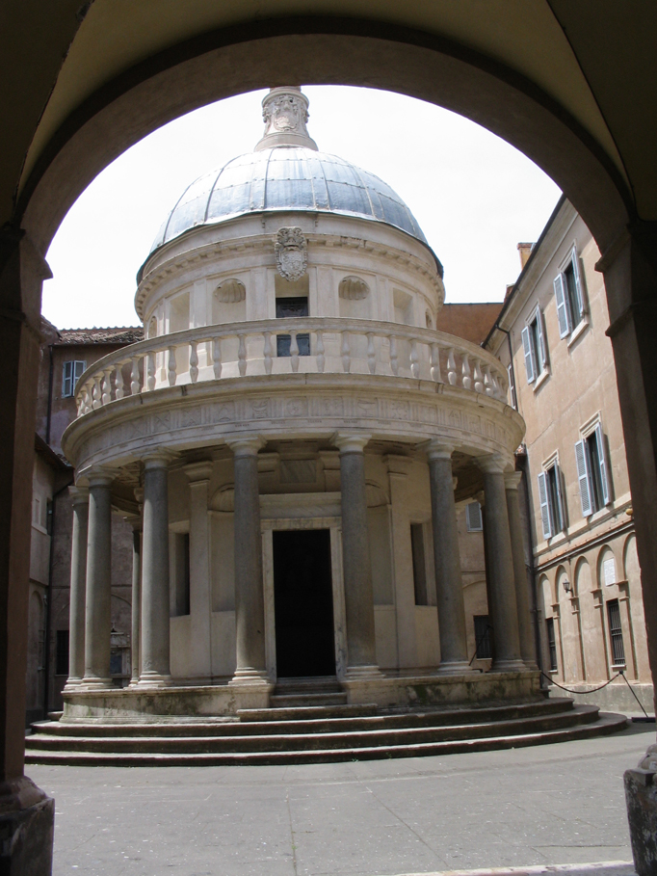 | 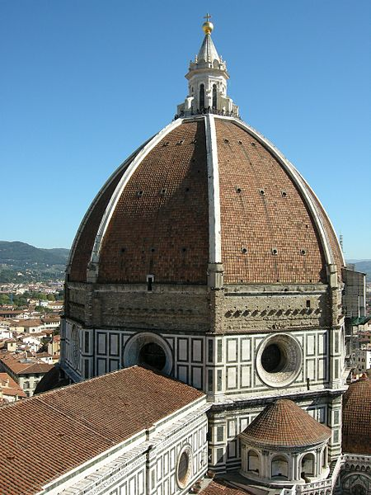
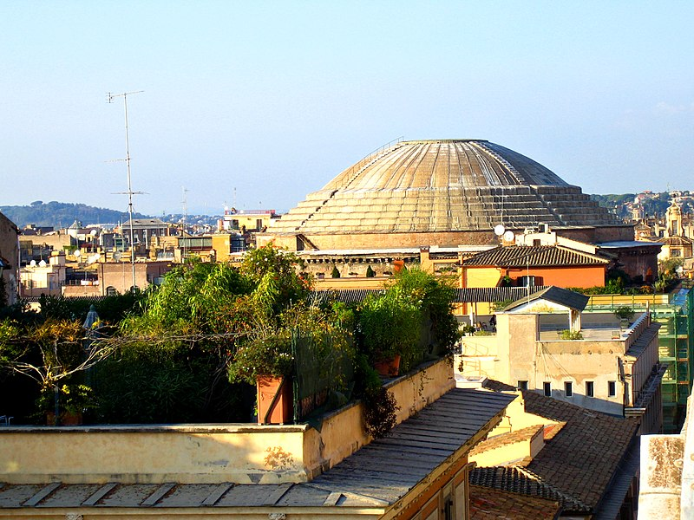
Zeus image was created by sailko and is published on Wikimedia Commons under a CC BY license, Image of David is courtesy of Wikimedia Commons and is public domain, Pillar image was created by Russell Yarwood and is published on Wikimedia Commons under a CC BY license, This Tempietto del Bramante image was created by Francesco and is published on Flicker under a CC BY license, Pantheon image was created by Anthony Majanlahti and is published on Wikimedia Commons under a CC BY license, Florence Cathedral image was created by Yellow.Cat and is published on Wikimedia Commons under a CC BY license.
3. What similarities do you notice between the Classical Greco-Roman art and architecture and the Renaissance art and architecture pictured above?

Definition Activity 3

Definition | The Renaissance, “rebirth” in French, was a cultural movement in the 14th-17th centuries during which European artists, scientists, and scholars, were inspired by Classical achievements of the Greeks and Romans, which they became aware of through ruins and Greco-Roman texts preserved by Islamic scholars in the Ottoman Empire.

➡ Directions: Examine the map and information below, then answer the questions on the following page.
Tracing the Ideas that Led to the Renaissance: Centers of Learning and Innovation in the Mediterranean World
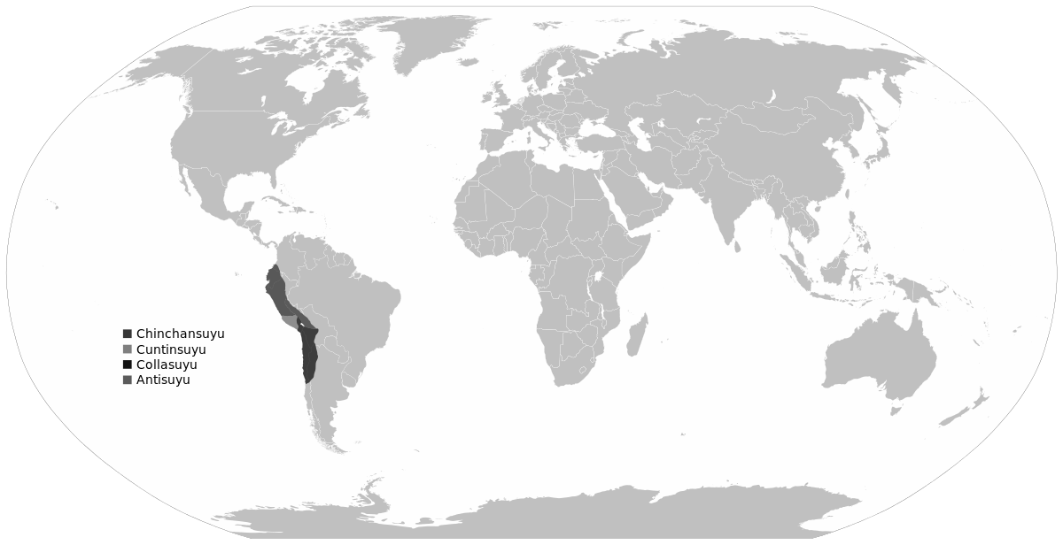
Source: Adapted from http://commons.wikimedia.org/wiki/File:BlankMap-World6.svg

Rome
Pax Romana
(27 BCE-180 CE)
During a period of few wars and strong emperors, Roman scholars, artists, architects, engineers, writers, and philosophers studied Greek texts and translated them into Latin and learned from Greek structures to create their own art, literary, and scientific achievements.
Athens
Golden Age of Pericles
(480 BCE- 404 BCE)
During a brief era of peace because of their strong military and strong leadership from Pericles, the Athenian government funded building projects like the Acropolis and literature, sculpture, and philosophy flourished.
Constantinople
Byzantine Empire
(323 CE- 1453 CE)
Ottoman Empire
(1453 CE- 1923 CE)
After the fall of the Western Roman Empire, Constantinople became the center of learning in the Christian world. Byzantine scholars preserved Greek and Roman texts. In addition, they built on the architectural achievements of Rome, building structures like Hagia Sophia and the Hippodrome.
Baghdad
Abbasid Caliphate
(750 CE- 1258 CE)
In the 800s, the Abbasid caliph in Baghdad started collecting Greek and Roman texts to build a great center of learning called the House of Wisdom. He sent scholars to Constantinople to obtain copies of ancient writings on literature, poetry, math, science, and art. The manuscripts were then translated into Arabic. Located in the Middle East, Baghdad also received knowledge from the Chinese and Indians from the east through trade. Islamic scientists made advances in medicine and astronomy.
Venice, Florence, and Milan
Italian City States
Renaissance
(1300s-1600s)
Birthplace of the Renaissance.
Map is courtesy of Wikimedia Commons and is public domain.
4. List the golden ages in the graphic above in chronological order.
5. Which civilization’s ideas were the foundation for collective learning in the Mediterranean world?
6. Identify two examples of innovation described in the chart.
7. Based on the dates and information provided, which civilization’s knowledge most directly influenced the start of the Renaissance?

FA | SQ 3: What was the Renaissance?  ➡ Directions: Using evidence from above, complete the Combined Context Expansion Sentence activity below to provide context for the rise of the Renaissance in Europe. An example using the Fall of Rome is provided.

Contextualize | Example: Fall of the Roman Empire  Who? Roman Empire  When? 476 CE  Where? Europe and North Africa  How?/Why? political turmoil, invasions, introduction of Christianity  Combined Context Expansion Sentence 1 In 476 CE, the Roman Empire which stretched across Europe and North Africa, collapsed because of political turmoil, invasions, and tensions caused by the introduction of Christianity. Writing Strategies Used: Prepositional phrase (In 476 CE) Conjunctions (because, and)  Combined Context Expansion Sentence 2 The Roman Empire, an expansive state that stretched across Europe and North Africa, collapsed in 476 CE due to political turmoil, invasions, and tensions caused by the introduction of Christianity. Writing Strategies Used: Appositives (...,an expansive state that stretched across Europe and North Africa,...) Conjunctions (due to, and)  Event: The Renaissance  Who?  When?  Where?  What?  Why?  How?  Combined Context Expansion  Sentence

